

ZTS-3000-FXJT-* -1-360

Polycarbonate wind direction sensor

Product Manual

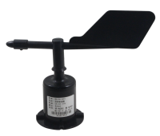

|  |  |
| --- | --- |
| 1 | Overview |

Wind direction sensors are used to measure the direction of the wind, the physical signal into electrical signals, which can be directly transmitted to the recording equipment for processing.

The shell of the sensor is made of polycarbonate composite material, which has good anti-corrosion and anti-corrosion characteristics. The cable connector is a military plug, which has good anti-corrosion and anti-corrosion performance, can ensure the long-term use of the instrument, and with the internal bearing system to ensure the accuracy of wind direction acquisition.

The wind direction sensor adopts low inertia wind vane and precision potentiometer, which is sensitive and accurate. The precision signal processing unit can output various signals according to the user's requirements. The circuit module PCB is made of military grade a material, which ensures the stability of the measured parameters and the quality of the electrical performance, while the electronic component is made of imported industrial grade chips, which make the whole system highly reliable against electromagnetic interference, it can ensure that the main engine can work normally in the range of ー20 ° C ー + 70 ° C, humidity 0% ー100% Rh (non-condensing) .

After the product upgrade, the output signal variety, wired output includes: analog signal (voltage, current) , digital signal RS485; wireless output includes: Lora, GPRS, 4G, wireless output in addition to Lora, the other forms can connect to the cloud platform to realize the monitoring and management of the intelligent terminal data. In the wired output, the analog output is 16 azimuth, and the RS485 output is 16 azimuth + 360 degree.

|  |  |
| --- | --- |
| 2 | Features |

(1) the sensor has compact design, high measuring precision, fast response and good interchangeability.

(2) to realize low cost, low price and high performance.

(3) the flange installation mode can realize the lower outlet line and the side outlet line, which is simple and convenient.

(4) the data transmission efficiency is high, the performance is reliable, guarantees the normal work.

(5) the power supply has wide application range, good linearity of data information and long signal transmission distance.

(6) it has two parameters of wind direction angle and wind direction, and the data is comprehensive and reliable.

|  |  |
| --- | --- |
| **3** | Scope of application |

This product can measure indoor and outdoor environment in any direction, the resolution is 0.1 ° , can be widely used in the field of construction machinery (cranes, crawler cranes, door cranes, tower cranes, etc.) , wind direction measurement of railway, port, Dock, power plant, meteorology, Ropeway, environment, greenhouse, breeding, air conditioning, energy saving monitoring, agriculture, medical treatment, clean space and so on.

|  |  |
| --- | --- |
| **4** | Product information |

The measuring range is 0-360 °

Accuracy: ± 1 °

Resolution: 0.1 °

Starting wind speed: ≤0.5 m/s

Maximum turning radius: 100mm

Output Signal: A: voltage signal (0-2v, 0-5v, 0-10V three choose one)

B: 4-20mA (current loop)

C: RS485(standard Modbus-RTU protocol, device default address: 01)

D: GPRS, 4G, Lora output

Supply voltage: 10-30V DC

Working Environment: Temperature: ー20 ° C ー70 ° C; humidity: ≤100% Rh

Protection level: IP65

Load capacity: voltage output: output resistance ≤250 ω; current output: ≤600 ω

|  |  |
| --- | --- |
| 5 | Use methods |

Wind direction sensors can be connected to a variety of differential input data acquisition device, data acquisition card, remote data acquisition module and other equipment, wiring description as follows:

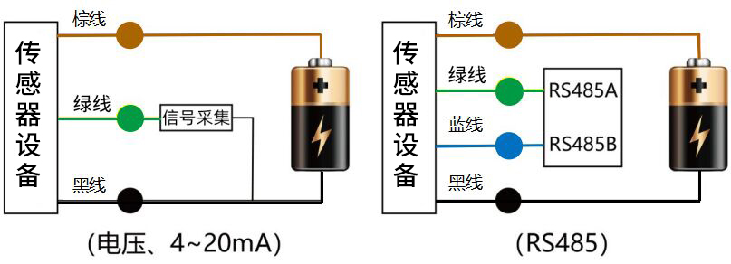

|  |  |
| --- | --- |
| **6** | Shape specifications |

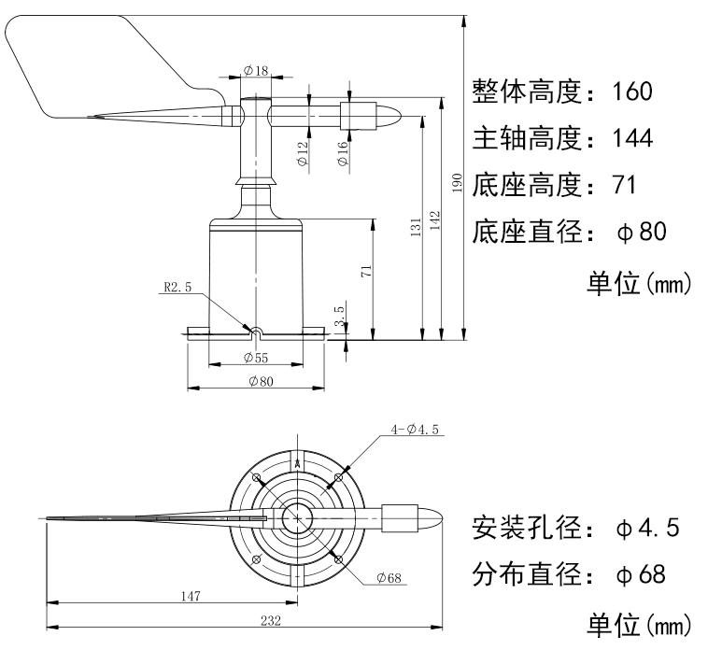

|  |  |
| --- | --- |
| 7 | Data conversion method |

|  |  |  |  |  |  |
| --- | --- | --- | --- | --- | --- |
|  | 0-2v | 0-5v | 0-10V | 4-20 Ma | RS485 |
| 北 | 1.9375-0.0625 | 4.84368-0.156255 | 9.6875-0.3125 | 19.5 to 4.5 | 0X00 |
| North-northeast | 0.0625-0.1875 | 0.156255-0.46875 | 0.3125-0.9375 | 4.5.5.5 | 0X01 |
| Northeast | 0.1875-0.3125 | 0.46875-0.781245 | 0.9375-1.5625 | 5.5 to 6.5 | 0X02 |
| Northeast | 0.3125-0.4375 | 0.781245-1.09374 | 1.5625-2.1875 | 6.5 to 7.5 | 0X03 |
| 东 | 0.4375-0.5625 | 1.09374-1.406235 | 2.1875-2.8125 | 7.5 to 8.5 | 0X04 |
| Southeast | 0.5625-0.6875 | 1.406235-1.71873 | 2.8125-3.4375 | 8.5 to 9.5 | 0X05 |
| Southeast | 0.6875-0.8125 | 1.71873-2.031225 | 3.4375-4.0625 | 9.5 to 10.5 | 0X06 |
| South-southeast | 0.8125-0.9375 | 2.031225-2.34372 | 4.0625-4.6875 | 10.5 to 11.5 | 0X07 |
| 南 | 0.9375-1.0625 | 2.34372-2.656215 | 4.6875-5.3125 | 11.5 to 12.5 | 0X08 |
| South by Southwest | 1.0625-1.1875 | 2.656215-2.96871 | 5.3125-5.9375 | 12.5 to 13.5 | 0X09 |
| Southwest | 1.1875-1.3125 | 2.96871-3.281205 | 5.9375-6.5625 | 13.5-14.5 | 0X0A |
| Southwest | 1.3125-1.4375 | 3.281205-3.5937 | 6.5625-7.1875 | 14.5 to 15.5 | 0X0B |
| 西 | 1.4375-1.5625 | 3.5937-3.906195 | 7.1875-7.8125 | 15.5 to 16.5 | 0X0C |
| Northwest | 1.5625-1.6875 | 3.906195-4.21869 | 7.8125-8.4375 | 16.5 to 17.5 | 0X0D |
| Northwest | 1.6875-1.8125 | 4.21869-4.531185 | 8.4375-9.0625 | 17.5-18.5 | 0X0E |
| North-northwest | 1.8125-1.9375 | 4.531185-4.84368 | 9.0625-9.6875 | 18.5 to 19.5 | 0 x 0 million |

RS485 signal (default address 01) :

Standard Modbus-RTU protocol, baud rate: 4800; parity bit: none; data bit: 8; stop bit: 1

**7.1 change of Address**

For example: change the address of a sensor with address 1 to 2, host → Slave

|  |  |  |  |  |  |  |  |
| --- | --- | --- | --- | --- | --- | --- | --- |
| Original address | Function codes | Start register high | Start register low | The starting address is high | The starting address is low | CRC16 is low | CRC16 high |
| 0X01 | 0X06 | 0X07 | 0XD0 | 0X00 | 0X02 | 0X08 | 0X86 |

If the sensor receives correctly, the data is returned in the same way.

Note: If you forget the original address of the sensor, you can use the broadcast address 0XFF instead, using 0XFF host can only receive a slave, and the return address is still the original address, can be used as an address query method.

**7.2 enquire data**

Query sensor (address 1-RRB- data (wind direction angle, wind direction) , host → slave

|  |  |  |  |  |  |  |  |
| --- | --- | --- | --- | --- | --- | --- | --- |
| Address | Function codes | Start register address is high | The start register address is low | Register length is high | Low register length | CRC16 is low | CRC16 high |
| 0X01 | 0X03 | 0X00 | 0X00 | 0X00 | 0X02 | 0XC4 | 0X0B |

If the sensor receives correctly, return the following data, from machine to host

|  |  |  |  |  |  |  |  |  |
| --- | --- | --- | --- | --- | --- | --- | --- | --- |
| Address | Function codes | Data Length | The wind direction angle is high | Low wind angle | The wind is high | The wind is low | CRC16 is low | CRC16 high |
| 0X01 | 0X03 | 0X04 | 0X02 | 0X9A | 0X00 | 0X03 | 0X9B | 0XA5 |
|  |  |  | Wind direction angle: 66.6 ° | | Wind: Northeast | |  |  |

|  |  |
| --- | --- |
| 8 | Wind direction 16 azimuth |

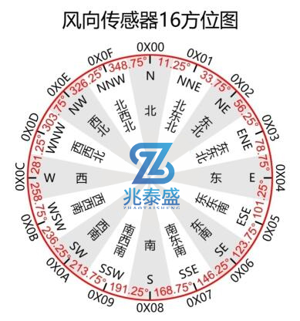

|  |  |
| --- | --- |
| 9 | Points to note when using |

(1) please read this manual carefully before use.

(2) please check the packing is intact, and check the sensor model and specifications are consistent with the products you choose.

(3) can not live wiring, wiring check after the completion of no error can be electrified.

(4) the user should not change the components and wires that have been soldered when the product leaves the factory.

(5) the sensor belongs to the precision device, the user should not disassemble when using, and can not touch the diaphragm, so as not to cause the product damage.

(6) to avoid viscous particles into the sensor, moisture, so as not to affect the measurement performance.

|  |  |
| --- | --- |
| 10 | Product warranty |

The warranty period of this product is one year. From the date of shipment, within 12 months, due to sensor quality problems (non-human damage) caused by failure, the company is responsible for free maintenance or replacement, after the warranty period only cost.